Design Overview

# Things we need to decide

* Overall design style
* Font
* Colour Scheme
* Target (I.e. device size)

# Overall design style

There are a number of different styles we can consider, and can use either a single style or a combination in some cases. However it is important to consider that our choice of UI must be consistent throughout the entire program. So for example we must consider the placement of elements, icon style and patterns.

## Skeuomorphism (Apple pre 2013)

Figure - Apple's iBooks, resemblance of a bookshelf

Skeuomorphism is using design cues from the visual world. So for example if we were designing a note taking application it would resemble the look of a notepad. This style of design does not necessarily have to replicate real life but does tend to suggest that the application is ‘real’. The most famous example of this design is Apple (pre 2013).

## Material Design (Google)

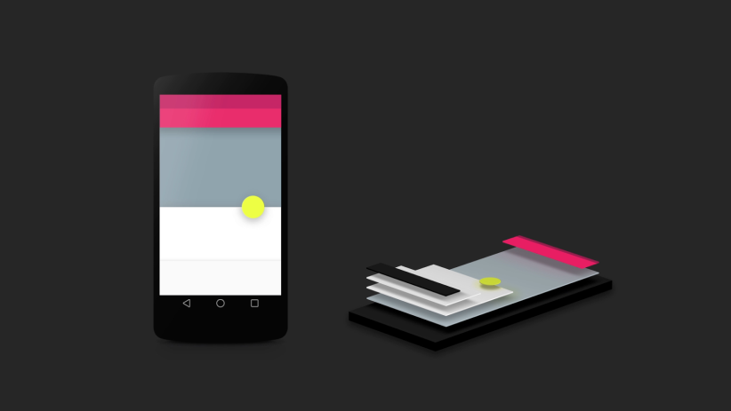Not as such a design style in itself, but a fantastic example of how a consistent design can be implemented across a large product (or in this case products). This style was created by google so that it could unify the look of all its interfaces across its many product lines such as Anrdoid, Chrome and Mail. It aims to be a flat style that takes some cues from Skeuomorphism but is far blockier in overall style. It places emphasis on movement with the transitions between multiple environments intended to be seamless. It makes heavy use of shadowing to give depth on an otherwise 2D screen. While it may be difficult to implement the design’s entire philosophy some elements could be useful, such as its use of simple shapes to convey meaning to the user and it’s consistent button placement.

Figure - Shows how Google intend to use 'layering' in Material Design

## Metro/Modern Design (Microsoft)

Figure - Windows Phone's email, showing large typeface etc.

Similar to Material Design in many ways but shows some important differences. Metro is rooted in the Bauhaus movement rather than Skeuomorphism which means that as a core principle anything superfluous is removed; for example in Apple’s iBooks Metro would probably remove the bookshelf background style for a block colour and use large pictures of the front of the books for the user to click or press. There is significant emphasis on large typefaces and large buttons. This style was developed to be used across multiple device sizes and styles i.e. it is for desktops, laptops and tablets.   
The Bauhaus movement is a concept where any design is taken to its absolute root, stripping away any superfluous features to create a clean design. Good examples of this are IKEA furniture and cantilever chairs.

Metro and Material Design are similar in end result however they come from a different starting point. Whereas Material Design is rooted in Skeuomorphism in that it takes something that is real and then creates a depiction of it on the screen to then be dumbed down, Metro is derived from the Bauhaus movement so it takes the core idea of what the function is trying to do and then turns it into a UI. E.g. When designing a keyboard Material design would take a real keyboard as inspiration, turn it into an on screen object and then flatten it into the more modern style. Metro would take the core concept of a keyboard (letters and buttons) and put just that as a UI.

Note: UI (User Interface) and UX (User Experience) are essentially interchangeable, but most modern UI’s are in fact UX’s really and so I will try and consistently use UX from now on as the more modern term.

# Design Process

1. **Product Definition** – Obviously first of all the product must be defined so that we can move to…
2. **Research –** check how the product will be used, i.e. who by, why etc
3. **Analyse –** analyse said research so that we know what to create
4. **Design** – Design the interface, initially using wireframes and moving onto prototyping then deliver the actual UX
5. **Implementation –** Combine the code and the design into the product
6. **Product Launch –** The finish line!

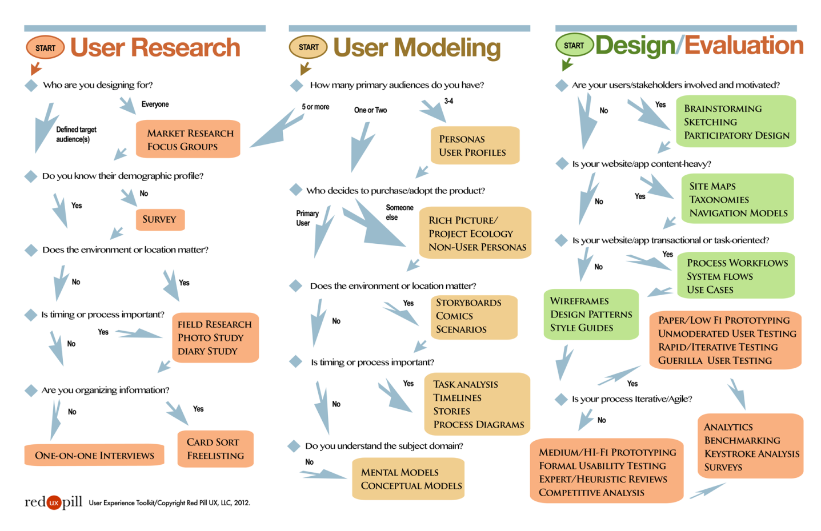

http://www.redpillux.com/tools/UX_DecisionFlow.png

References: The Guide to UX Design Process and Documentation